Packet Tracer Skills Integration Lab
Solved Configuration Guide
CCNA Exploration – Routing Protocols and Concepts

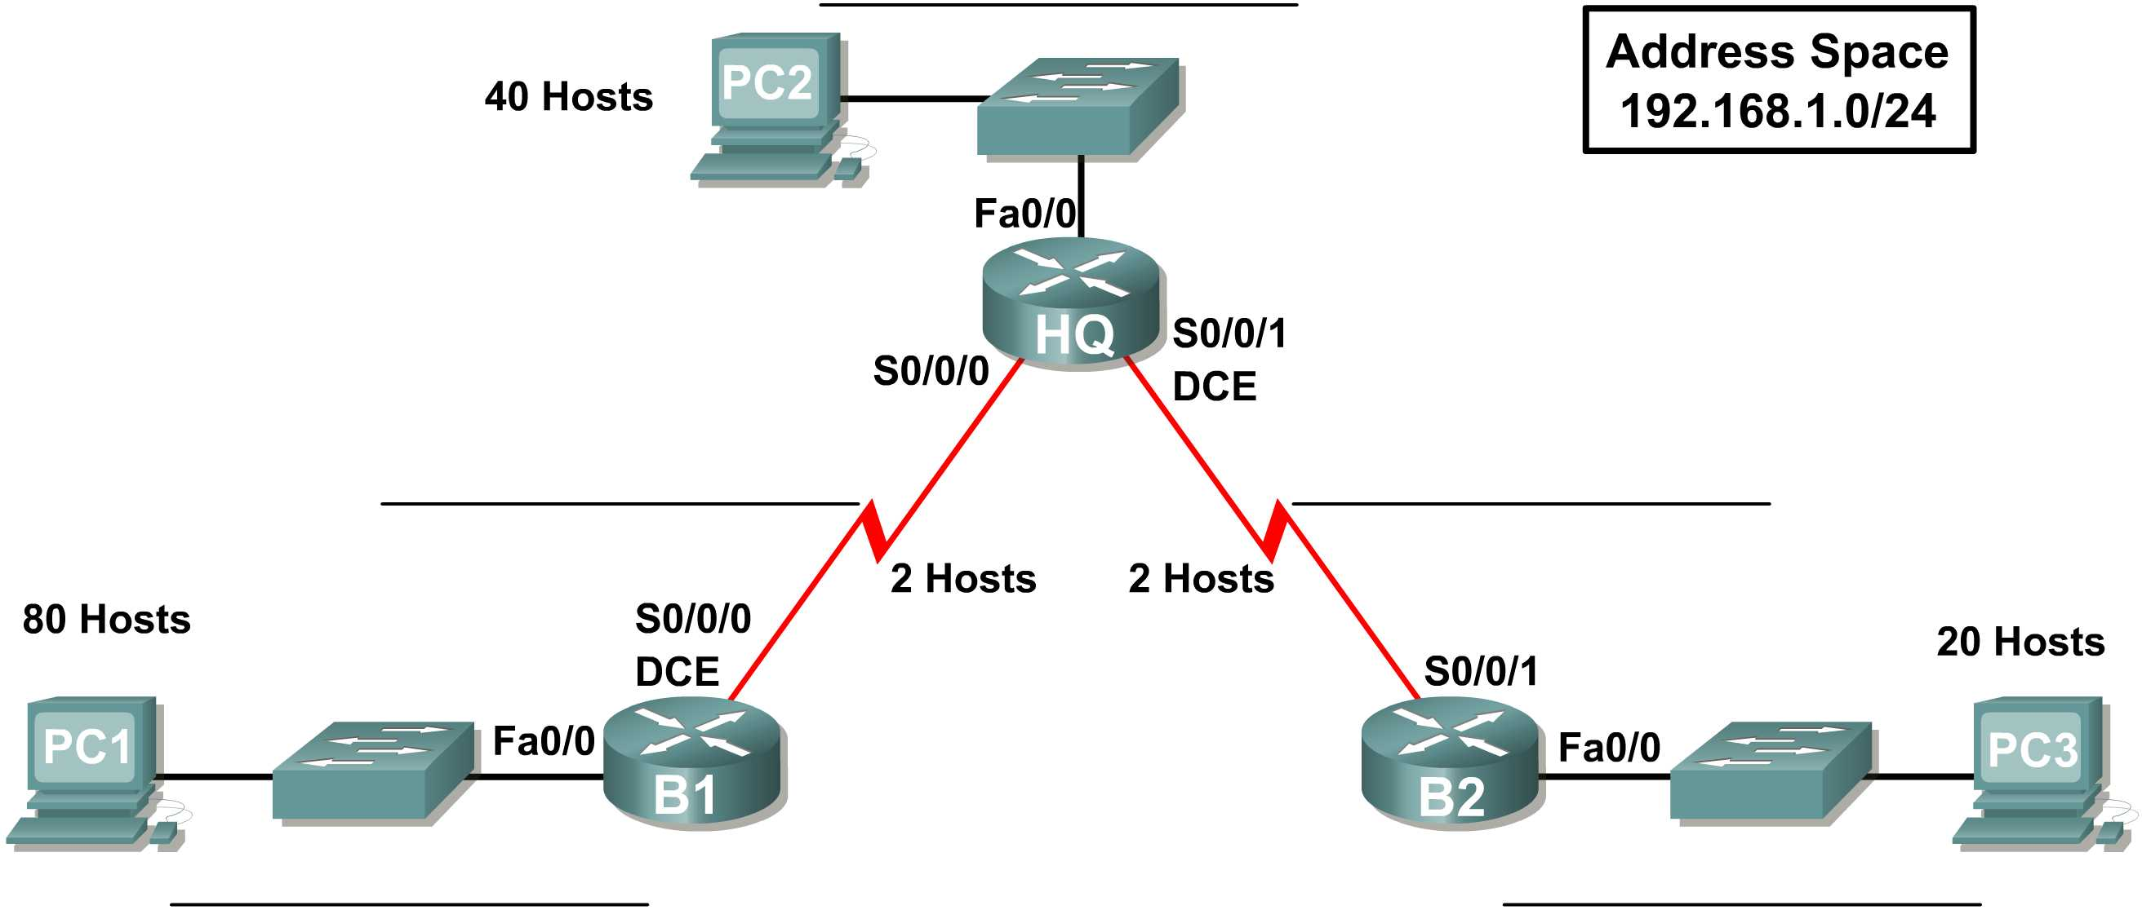

1. Lab Objectives
- Design and document an addressing scheme.
- Select equipment and cable the devices.
- Apply basic router and PC configurations.
- Verify connectivity between all devices.
- Identify Layer 2 and Layer 3 addresses used to forward packets.

2. VLSM Addressing Scheme
The addressing scheme follows the lab instructions: start with the largest LAN, allocate the WAN links after the LAN subnets, assign the first usable LAN address to the router interface, the last usable address to the PC, and the first WAN address to HQ.
Network | Hosts | Network/CIDR | Subnet Mask | Usable Host Range | Broadcast
B1 LAN | 80 | 192.168.1.0/25 | 255.255.255.128 | 192.168.1.1 – 192.168.1.126 | 192.168.1.127
HQ LAN | 40 | 192.168.1.128/26 | 255.255.255.192 | 192.168.1.129 – 192.168.1.190 | 192.168.1.191
B2 LAN | 20 | 192.168.1.192/27 | 255.255.255.224 | 192.168.1.193 – 192.168.1.222 | 192.168.1.223
HQ–B1 WAN | 2 | 192.168.1.224/30 | 255.255.255.252 | 192.168.1.225 – 192.168.1.226 | 192.168.1.227
HQ–B2 WAN | 2 | 192.168.1.228/30 | 255.255.255.252 | 192.168.1.229 – 192.168.1.230 | 192.168.1.231

3. Device Addressing Table
Device | Interface | IP Address | Subnet Mask | Default Gateway
HQ | Fa0/0 | 192.168.1.129 | 255.255.255.192 | N/A
HQ | S0/0/0 | 192.168.1.225 | 255.255.255.252 | N/A
HQ | S0/0/1 | 192.168.1.229 | 255.255.255.252 | N/A
B1 | Fa0/0 | 192.168.1.1 | 255.255.255.128 | N/A
B1 | S0/0/0 | 192.168.1.226 | 255.255.255.252 | N/A
B2 | Fa0/0 | 192.168.1.193 | 255.255.255.224 | N/A
B2 | S0/0/1 | 192.168.1.230 | 255.255.255.252 | N/A
PC1 | NIC | 192.168.1.126 | 255.255.255.128 | 192.168.1.1
PC2 | NIC | 192.168.1.190 | 255.255.255.192 | 192.168.1.129
PC3 | NIC | 192.168.1.222 | 255.255.255.224 | 192.168.1.193

4. Router Configuration

B1
enable
configure terminal
hostname B1
enable secret class
line console 0
password cisco
login
exit
line vty 0 4
password cisco
login
exit
interface fastethernet 0/0
ip address 192.168.1.1 255.255.255.128
no shutdown
exit
interface serial 0/0/0
ip address 192.168.1.226 255.255.255.252
no shutdown
exit
end
copy running-config startup-config

HQ
enable
configure terminal
hostname HQ
enable secret class
line console 0
password cisco
login
exit
line vty 0 4
password cisco
login
exit
interface fastethernet 0/0
ip address 192.168.1.129 255.255.255.192
no shutdown
exit
interface serial 0/0/0
ip address 192.168.1.225 255.255.255.252
clock rate 64000
no shutdown
exit
interface serial 0/0/1
ip address 192.168.1.229 255.255.255.252
clock rate 64000
no shutdown
exit
end
copy running-config startup-config

B2
enable
configure terminal
hostname B2
enable secret class
line console 0
password cisco
login
exit
line vty 0 4
password cisco
login
exit
interface fastethernet 0/0
ip address 192.168.1.193 255.255.255.224
no shutdown
exit
interface serial 0/0/1
ip address 192.168.1.230 255.255.255.252
no shutdown
exit
end
copy running-config startup-config

5. PC Configuration
PC1: IP Address = 192.168.1.126; Subnet Mask = 255.255.255.128; Default Gateway = 192.168.1.1
PC2: IP Address = 192.168.1.190; Subnet Mask = 255.255.255.192; Default Gateway = 192.168.1.129
PC3: IP Address = 192.168.1.222; Subnet Mask = 255.255.255.224; Default Gateway = 192.168.1.193

6. Connectivity Verification
The provided lab states that RIP routing is already configured. After addressing and interface configuration, test:
- PC1: ping 192.168.1.190 (PC1 → PC2)
- PC1: ping 192.168.1.222 (PC1 → PC3)
- PC3: ping 192.168.1.190 (PC3 → PC2)
Expected result: Successful end-to-end connectivity. If a ping fails, troubleshoot the relevant interface, addressing, cabling, or routing configuration.

7. Router Verification Commands
show ip interface brief
show ip route
show ip protocols
All required interfaces should show an operational state (up/up). RIP routes should be present where applicable.

8. Task 5 – Layer 2 and Layer 3 Addresses
Create a Simple PDU from PC1 to PC3 in Simulation Mode and filter for ICMP. The Layer 3 source and destination remain unchanged across the routed path, while Layer 2 addresses change at each hop.
Hop | Layer 3 Source | Layer 3 Destination | Layer 2 Source | Layer 2 Destination
PC1 → B1 | 192.168.1.126 | 192.168.1.222 | PC1 MAC | B1 Fa0/0 MAC
B1 → HQ | 192.168.1.126 | 192.168.1.222 | B1 S0/0/0 MAC | HQ S0/0/0 MAC
HQ → B2 | 192.168.1.126 | 192.168.1.222 | HQ S0/0/1 MAC | B2 S0/0/1 MAC
B2 → PC3 | 192.168.1.126 | 192.168.1.222 | B2 Fa0/0 MAC | PC3 MAC
Note: The actual MAC addresses must be copied from Packet Tracer's PDU details; they are not specified in the lab PDF.

9. Final Checklist
- VLSM subnets entered correctly.
- All router interfaces have the assigned IP addresses.
- All required interfaces are enabled with no shutdown.
- Serial DCE clock rate is set to 64000 where required.
- Console/VTY password is cisco.
- Enable secret is class.
- PC1, PC2, and PC3 have correct IP, mask, and gateway.
- PC1 can ping PC2.
- PC1 can ping PC3.
- PC3 can ping PC2.
- Task 5 Layer 2 MAC addresses are recorded from Simulation Mode.

Source
Prepared from the uploaded Cisco Packet Tracer Skills Integration Instructions. The source specifies the VLSM task, addressing assignment rules, router password/clock-rate requirements, PC configuration, connectivity tests, and Layer 2/Layer 3 packet-analysis tasks.

